UDC 37.091.64

Organizing Committee of the Conference

SPbPU

Formatting of MTEE articles using MS Word

This document is intended to assist authors in using MS Word software to format articles planned for publication in the MTEE Conference Proceedings. It contains both basic recommendations for the content of articles and a brief description of the applicable tools.

This file, as well as the provided template, contains pre-configured styles that facilitate effortless and effective adjustment of the draft paper in accordance with the established requirements. Please use MS Word 2010 or newer software when working with it. The Styles menu can be accessed from the ribbon menu by selecting Styles, or by pressing Alt + Ctrl + Shift + S on Windows (Figure 1).

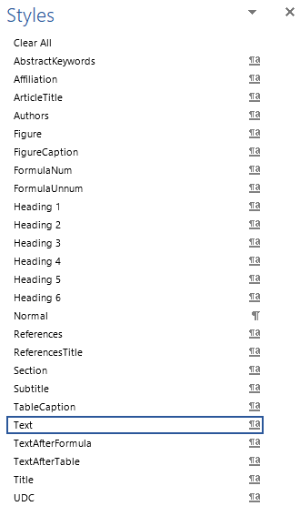

Figure 1 – Screenshot of the Styles menu (Microsoft Office 2019)

To apply a preset, place the cursor within the line or paragraph to be styled, and click the preset in the Styles menu. Please do not add indentation manually or capitalize where it is not justified by syntax and is not part of an established term or trade name: the text will be adjusted automatically. The elements of the article are formatted as follows (Table 1):

Table 1. Item Style Names

|  |  |
| --- | --- |
| Element | Style |
| UDC | UDC |
| F.M. Surname of the authors | Authors |
| Organization | Affiliation |
| Title | ArticleTitle |
| Abstract (optional) | AbstractKeywords |
| Keywords (optional) | AbstractKeywords |
| Text | Text |
| Figure | Figure |
| Figure caption | FigureCaption |
| Table caption | TableCaption |
| Table | Text |
| Text after a table | TextAfterTable |
| Formula | FormulaUnnum |
| Numbered formula | FormulaNum |
| Text after a formula | TextAfterFormula |
| References title | ReferencesTitle |
| References | References |

Use the TextAfterTable style when a new paragraph begins after a table. If using numbered formulas, type a tab character (Tab), a formula, another tab character, a number, and apply the FormulaNum style.

Example of a numbered formula (1)

The Text After Formula style is used for the continuation of the paragraph that began before one, or if the values used in the formula are specified. In this example, the paragraph after the Table 1 is styled with TextAfterTable, and the text after (1) is styled with regular Text.

When compiling the text of the article, the Organizing Committee of the Conference recommends including the following sections: "Introduction", "Relevance", "Objectives" and "Conclusions".

When designing the illustrations, we ask you to take into account that the conference proceedings will be printed with a scale reduction of about 30%. Images should not contain small details, captions on them at the current scale should have a font size of at least 10. If showcasing small elements is necessary, we recommend using insets to place a high-detail element on a low-detail image (Figure 2). When presenting graphs or diagrams where both the general trend and local behavior are important, a specific range can be magnified (Figure 3).

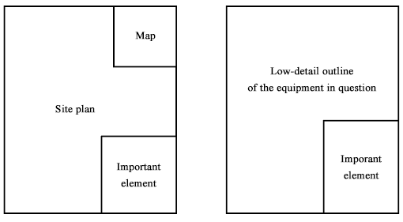

Figure 2 – Examples of image layout. On the left, there are three levels of detail: geographical location, territory plan, and modified object. On the right, there are two levels of detail: the sketch of the entire product and the part to be modified.

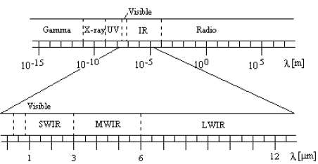

Figure 3 – The electromagnetic spectrum, magnified at the wavelengths of primary interest for optical sensors [1, p. 6].

The figures must be referenced in the text. Drawings consisting of separately inserted elements are not allowed.

References to literature should not be automatic, they should be included in the text of the article in square brackets after the citation (the number of the source indicated as [1], [2], etc.). References to several sources with pages are separated from each other by a semicolon ([1, pp. 5-7; 2, p. 4]). In the list of references, sources are numbered with Arabic numerals with a dot without brackets (1., 2. etc.). All sources from the list of references must be referenced in the text. References are numbered in the order in which they appear in the text of the article. Automatic numbering of paragraphs, lists of enumerations, automatic marking of indents (by any sign) are not allowed.

References

1. Bjorn Hassler, Atmospheric Transmission Models for Infrared Wavelengths, a Master Thesis // Linkoping University, Sweden, 1998.