**VIII International Scientific and Practical Conference**

**"Modern Technologies and Energy Economics"**

On April 24, 2025, the annual international scientific and practical conference for students, graduate students, young scientists and researchers "Modern Technologies and Energy Economics" (MTEE) will be held in a remote format.

The conference is organized by Peter the Great St. Petersburg Polytechnic University, Belarusian National Technical University and Kazan State Power Engineering University.

The conference will be held in the following sections:

1. Economics and Management in Energy;
2. Modern aspects of Heat and Nuclear Power Engineering;
3. Energy-Efficient Technologies;
4. IT Technologies in Energy;
5. Hydrogen Energy.

The working languages of the conference are Russian and English.

From March 15 to April 10, 2025 (inclusive), everyone wishing to take part in the Conference is welcome to submit reports to the organizing committee for selection for participation and fill out an application. Forms for registration and submission will be presented on the official website of the Conference, available from March 1.

**Submission of reports is carried out only through the official website of the Conference.**

The guidelines for preparation of reports are presented below. Applications received not through the Conference website are not considered and not registered.

Conference e-mail: mtee-international@yandex.ru

Organizational questions can be sent to the conference e-mail and the organizing committee: Phone: +7961-733-99-89, Danilova Daria Ruslanovna.

Examination and competitive selection of submitted applications is carried out by the Organizing Committee of the Conference.

Organizing Committee of the Conference:

* Olga Valentinovna Novikova, Candidate of Economic Sciences, Associate Professor of the Higher School of Nuclear and Thermal Power Engineering and the Higher School of Engineering and Economics of SPbPU;
* Yaroslav Alexandrovich Vladimirov, Candidate of Technical Sciences, Associate Professor of the Higher School of Nuclear and Thermal Power Engineering, SPbPU;
* Natalia Anatolyevna Yudina, Candidate of Chemical Sciences, Associate Professor of the Department of Economics, "Economics and Organization of Production", KSPEU;
* Ekaterina Pavlovna Korsak, Chairman of the Council of Young Scientists of BNTU, Doctor of Economic Sciences, Senior Lecturer of the Department of Economics and Organization of Energy, BNTU.

Scientific Committee of the Conference (composition to be confirmed):

* Vitaly Vladimirovich Sergeev, Doctor of Technical Sciences, Corresponding Member of the Russian Academy of Sciences, Professor of the Higher School of Nuclear and Thermal Power Engineering of the Institute of Energy, Vice-Rector of the SPbPU";
* Viktor Valentinovich Barskov, Doctor of Technical Sciences, Associate Professor, Acting Director of the Institute of Energy, SPbPU;
* Alexander Antonovich Kalyutik, Candidate of Technical Sciences, Associate Professor, Director of the Higher School of Nuclear and Thermal Power Engineering, SPbPU;
* Irina Gareevna Akhmetova, Doctor of Technical Sciences, Vice-Rector for Development and Innovation, KSPEU, Head of the Department of Engineering, "Economics and Organization of Production" KSPEU, member of the Scientific and Technical Council NP "Market Council";
* Evgeny Gennadievich Ponomarenko, Candidate of Technical Sciences, Associate Professor, Dean of the Faculty of Power Engineering, BNTU;
* Tatyana Feliksovna Mantserova, Candidate of Economic Sciences, Associate Professor, Head of the Department "Economics and Organization of Energy", BNTU;

Editorial Committee of the Conference:

* Daria Danilova, Higher School of Nuclear and Thermal Power Engineering, Institute of Energy, SPbPU;
* Svetlana Kayukova, Higher School of Nuclear and Thermal Power Engineering, Institute of Energy, SPbPU.

Requirements for the content of materials for publication in the conference proceedings

**"Modern Technologies and Energy Economics"**

Submitted materials must meet the standard requirements for a scientific article, and must contain:

* the relevance (motivation) of the work, a brief overview of its topic;
* research methods;
* goals and objectives of the work;
* presentation of new results obtained personally by the author (authors);
* brief conclusions made on the basis of the analysis of the results obtained by the author (authors) and presented in the work;
* list of references (3 to 10 sources);
* the originality of the work of least 70%.

Review and abstract works are not accepted for publication.

Failure to comply with the formal requirements automatically entails a rejection.

The reasons for the rejection of works are not communicated to their authors.

All submitted works will undergo a two-stage scientific review, based on the results of which a decision will be made on the possibility of publication.

For all works, an EXPERT OPINION is uploaded through the site by the authors themselves.

Works admitted to publication will be indexed in the RSCI (elibrary).

The best papers will be recommended for publication in peer-reviewed journals indexed in Scopus and Web of Science.

Requirements for the formatting of the text of papers for publication in the conference proceedings

**"Modern Technologies and Energy Economics"**

When preparing an article, we recommend using the attached "MTEE Template" and "MTEE Sample Article", containing, among other things, detailed information on the use of the template. The following information will be useful for those who decide to format articles manually.

Reports are submitted only as files in Microsoft Word format (*.doc file format) with the following settings:

* font – Times New Roman (Cyr);
* font style – normal (normal);
* font size – 14;
* line spacing – 1; the intervals between the paragraphs of the text of the article are zero;
* page parameters: paper size – A4; margins: top, left, right, bottom – 20 mm;
* in formulas, the size of the characters should match the font size of the main text of the article.

The permissible volume of the work is no more than three full pages (including a list of references).

When designing the illustrations, we ask to take into account that the conference proceedings will be printed with a scale reduction of about 30%. Images should not contain small details, captions on them at the current scale should have a font size of at least 10. Figures are made as single pictures and are placed between paragraphs of text: text wrapping is not allowed. All figures are numbered, captions to figures are made below them in font size 12. The figures must be referenced in the text. Drawings made up of separate elements are not allowed. Numbers, symbols and text inside the picture field must be readable (large enough).

Tables are numbered and must have titles (printed before the table, font size – 12), they must be referenced in the text.

References to literature should not be automatic, they are given in the text of the article in square brackets after the citation (the number of the source indicated as [1], [2], etc.). References to several sources with pages are separated from each other by a semicolon ([1, pp. 5-7; 2, p. 4]). In the list of references, sources are numbered with Arabic numerals with a dot without brackets (1., 2., etc.). All sources from the list of references must be referenced in the text. References are numbered in the order in which they appear in the text of the article.

Automatic numbering of paragraphs, lists of enumerations, automatic marking of indents (with any character) are not allowed!

The text of the article is arranged as follows (see Appendix 1):

* on the first line (in the upper left corner) the UDC of the work is indicated;
* on the next line (align to the right): initials and, separated by a space, the surname of the author (authors);
* on the next line (align to the right): the name of the organization(s) in lowercase letters;
* positions and academic degrees of the authors are not indicated;
* then one blank line, on the next line (aligned in the center): TITLE OF THE ARTICLE (in capital letters);
* if the co-authors of the work represent different organizations, then the "header" of the article should contain notes (see Appendix 1);
* after one blank line: the text of the work (paragraphs begin with an indented line at 1 cm);
* at the end of the text, one blank line is left, then the word REFERENCES: (centered) is written, and below is a list of cited sources.
* the word "REFERENCES" and the list of cited sources are formatted in font size 12.

Appendix 1

UDC 661.961

I.I. Ivanov1, P.P. Petrov2

1Peter the Great St. Petersburg Polytechnic University

2LLC "Vodorod"

IDENTIFICATION OF PROSPECTS FOR HYDROGEN STORAGE AND TRANSPORTATION

*Introduction.* Since the entry into force of the Paris Climate Agreement in 2016, the relevance of decarbonizing energy systems has increased. However, without the introduction of new technologies that....

*Relevance.* In addition to solar and wind energy, hydrogen energy is gaining popularity in the world market....

*Objectives.* Identification of the most promising hydrogen technologies in .... The object of the research is ..., and the subject of the research is .... Taking into account the goal, the following tasks were solved in the study:

1. …

2. …

3. …

Having analyzed the methods of storage and transportation (Table 1, Figure 1), it can be stated that hydrogen liquefaction has optimal indicators of cost, specific volume, storage and transportation weight.

Table 1: Key Indicators of H2 Storage Methods [2][3]

|  |  |  |  |  |
| --- | --- | --- | --- | --- |
| Storage method/indicator | Specific energy consumption | Specific storage capacity | Specific Weight of Storage | Cost of hydrogen storage |
| Units | kWh/kg H2 | dm3/kg H2 | kg/kg H2 | $/kg H2 |
| Hydrogen at low pressure | 0.39 | 1020 | — | 0.5 |
| Hydrogen at high pressure | 0.93 | 81 | 16.0 | 0.5 |
| Hydrogen in hydrides | 1.16 | 22 | 76.9 | 2.5 |
| Liquefied hydrogen | 10.5 | 14 | 7.0 | 1.2 |

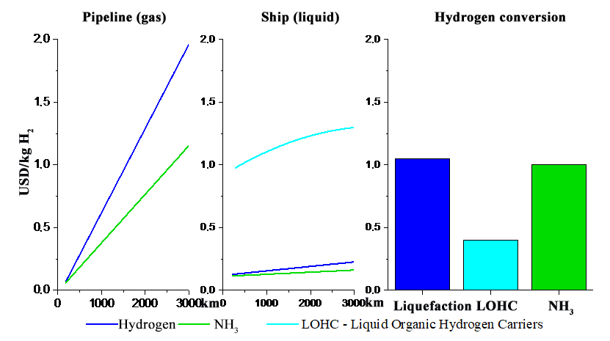

Figure 1 – Costs of storing and transporting hydrogen by pipelines and vessels, as well as costs of liquefaction and conversion of hydrogen [1]

The risk analysis identified key constraints:

1. …

2. …

…

Calculation results....

…

*Conclusions*. The most promising method of storage for Russia is liquefied hydrogen, and transportation by tankers on water and by trucks on land.

LITERATURE

1. The Future of Hydrogen // IEA URL: https://iea.blob.core.windows.net/assets/8ab 96d80-f2a5-4714-8eb5-7d3c157599a4/English-Future-Hydrogen-ES.pdf

2. R. V. Radchenko, A. S. Mokrushin, V. V. Tulpa Hydrogen in Energy: Study Materials. - Ekaterinburg: Ural University Publishing House, 2014. - 229 p.

3. Hydrogen Economy - the Way to Low-Carbon Development // Energy Center of the Moscow School of Management SKOLKOVO URL: https://energy.skolkovo.ru/downloads/documents/  
SEneC/Research/SKOLKOVO_EneC_Hydrogen-economy_Rus.pdf